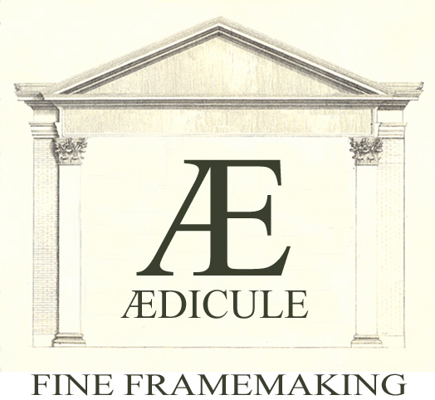

Condition Report

2 ‘Bergere Chairs’
93 x 57 x 74 cm

Overall condition: poor
The chairs are fabricated out of different wood species. Wormholes are to be found over the entire chairs. Most joints are pretty solid although all pegs have ‘moved’ and are sticking out a few mm. Countless cracks and dents are to be found on all parts of the chairs but are really noticeable on arms, legs and rails. It appears that both chairs have been upholstered many times and this has left numerous nail holes in these areas. A paint wash has been applied on top of the wood and is flaking off but also hides most of all the fore mentioned cracks. Some parts of the legs and arms seemed to have been exposed to excessive heat and have turned black.

3225 Sacramento Street San Francisco, California 94115
Telephone (415) 771-5837 Facsimile (415) 771-5838
aedicule.com

Approach

Because of the condition of the chairs but also because of its prominent place they would be staged in, I decided to handle these in the most conservative way possible, using only materials that would have been used originally. This way, everything is very easily reversible but it has also some ‘negative side effects’: All the cracks and holes could make for a very unstable surface and also wood grains could react at any time during the gilding process. This did indeed occur on two parts of the back side of the chairs.

3225 Sacramento Street San Francisco, California 94115
Telephone (415) 771-5837 Facsimile (415) 771-5838
aedicule.com

Process:

Step 1: Cleaning:
Paint was stripped with warm water and sponge. In hard to reach areas a solution of hydrochloric acid with water was used (1/20) to remove thick layers of paint and residue. These sections were immediately washed out several times with water followed by an overall “water wash” over the entire chairs. Chairs were left alone for an entire week to rest and dry.

Step 2: Preparation:
Chairs received a ‘rough sanding’ to remove any left over paint and to open up the surface grain. After this, they received two layers of “Hot-Glue” (a hot water and hyde glue mixture) to de-grease the wood surface.

Step 3: Sanding and filling:
Another rough sanding was followed by a finer sanding. Pâte (combination of silk paper, hyde glue and chalk) was used to fill in all lost sections/holes and cracks. Missing ornamentations were re-carved. Pegs were ‘pushed back in’ as much as possible and reshaped so they were even with the overall surface.

Step 4: Application of gesso

Step 5: Recutting and sanding of gesso

Step 6: Application of yellow and red clay:
Yellow (Selhamin) and, red (Charbonnel) clay was applied. After drying, a slightly moist rag was used to buff up the clay.

Step 7: Application of gold:
“Double” gold was used, 23 3/4Karat. Highlights were burnished.

*Trobas-Skin glue (280 bloom, 100 Millipoises) was used for preparation of gesso and clay in different volumes.

3225 Sacramento Street San Francisco, California 94115
Telephone (415) 771-5837 Facsimile (415) 771-5838
aedicule.com

